Part Number: PT948-1M160

Kit Contents

|  |  |  |
| --- | --- | --- |
| Item # | Quantity Reqd. | Description |
| 1 | 1 | Driver Side Front Door Sill |
| 2 | 1 | Driver Side Rear Door Sill |
| 3 | 1 | Passenger Side Front Door Sill |
| 4 | 1 | Passenger Side Rear Door Sill |

Hardware Bag Contents

|  |  |  |
| --- | --- | --- |
| Item # | Quantity Reqd. | Description |
|  |  |  |
| 2 |  |  |
| 3 |  |  |
|  |  |  |

Additional Items Required For Installation

|  |  |  |
| --- | --- | --- |
| Item # | Quantity Reqd. | Description |
| 1 |  |  |
| 2 |  |  |
| 3 |  |  |
|  |  |  |

Conflicts

|  |
| --- |
| None |

Recommended Tools

|  |  |
| --- | --- |
| Personal & Vehicle Protection | Notes |
| Safety Glasses/Gloves | Optional |
|  |  |
|  |  |
| Special Tools | Notes |
| Non-Intrusive IR Temperature Probe / Gun |  |
| Soft Felt Block or Roller | 0.5” Thick with double bevel edges (ie: Sutherland Felt 32S1 or 3M 71606) OR 2” Silicone/Rubber Pressure Roller |
|  |  |
| Installation Tools | Notes |
| Heat Gun | Part & Vehicle must be over 70ºF |
| Lint-Free Scratch Resistant Cloth | WypAll L40 Disposable Cloth (Recommended) |
| Masking Tape |  |
| Special Chemicals | Notes |
| Cleaner | Soap & Water Mixture |
| Water | Bottled & Distilled |
|  |  |

General Applicability

|  |
| --- |
| All iA models |

Recommended Sequence of Application

|  |  |
| --- | --- |
| Item # | Accessory |
| 1 |  |
| 2 |  |
| 3 |  |
|  |  |

\*Mandatory

Vehicle Service Parts (may be required for reassembly)

|  |  |  |
| --- | --- | --- |
| Item # | Quantity Reqd. | Description |
| 1 |  |  |
| 2 |  |  |
| 3 |  |  |
|  |  |  |

Legend

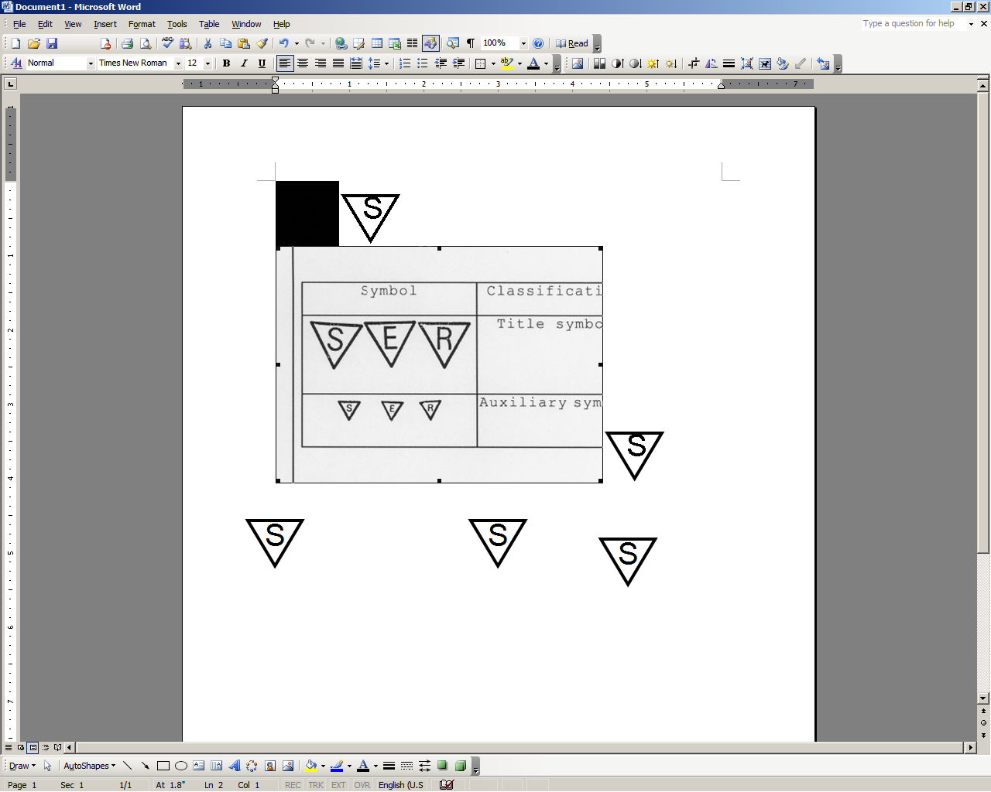

**STOP:** Damage to the vehicle may occur. Do not proceed until process has been complied with.

**OPERATOR SAFETY:** Use caution to avoid risk of injury.

**CAUTION:** A process that must be carefully observed in order to reduce the risk of damage to the accessory/vehicle and to ensure a quality installation.

**TOOLS & EQUIPMENT:** Used in Figures calls out the specific tools and equipment recommended for this process.

**REVISION MARK:** This mark highlights a change in installation with respect to previous issue.  
  
**SAFETY TORQUE:** This mark indicates that torque is related to safety.



Care must be taken when installing this accessory to ensure damage does not occur to the vehicle. The installation of this accessory should follow approved guidelines to ensure a quality installation.

These guidelines can be found in the "Accessory Installation Practices" document.

This document covers such items as:-

* Vehicle Protection (use of covers and blankets, cleaning chemicals, etc.).
* Safety (eye protection, rechecking torque procedure, etc.).
* Vehicle Disassembly/Reassembly (panel removal, part storage, etc.).
* Electrical Component Disassembly/Reassembly (battery disconnection, connector removal, etc.).

Please see your Scion dealer for a copy of this document.

Prepare for the Installation.

* 1. Thoroughly clean all installation surfaces.

caution_2**NOTE:** Always use a clean WypAll lint-free scratch resistant cloth and shake the soap & water mixture well.

* 1. Apply the soap & water mixture to the cloth. Do not spray cleaning solutions directly onto the vehicle (Fig. 1-1).

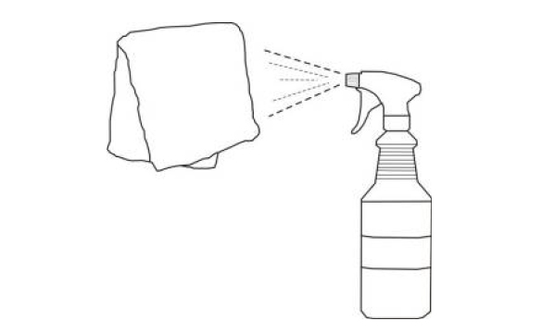

Fig. 1-1

WypAll cloth



* 1. Clean the surfaces thoroughly and wipe dry immediately with a new clean cloth. Do not allow the cleaner to air dry (Fig. 1-2).

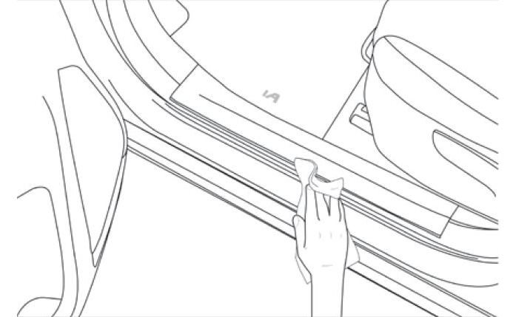

Fig. 1-2

* 1. Apply water to a clean cloth. Clean the surface thoroughly to ensure any soap & water mixture is completely removed. Wipe dry with a new clean cloth.
  2. Ensure the door sill protector and the vehicle installation surfaces are between 70°F and 110°F at the time of installation. A heat source may be used to maintain a minimum temperature.
  3. Inspect the kit for contents and any damage (Fig. 1-3).

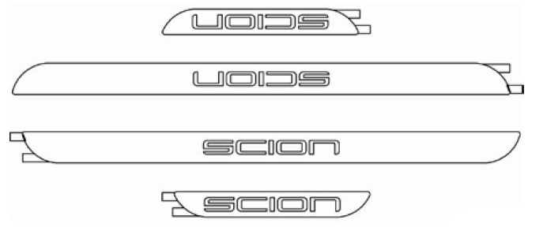

Fig. 1-3

##### Mark the Installation Location –Front Door Sills.

* 1. Place a piece of masking tape flush along the front edge of the driver front door scuff plate (where it meets the kick panel) across the painted door sill surface to create a measurement reference line (Fig. 2-1).

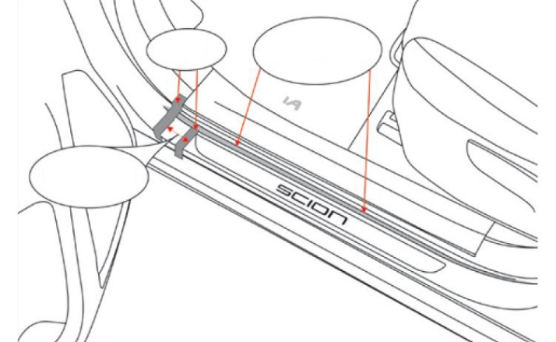

Fig. 2-1

Tape



Tape

27mm

±2mm

Character bump

* 1. Measure 27mm (±2mm) from the back edge of the tape that borders the scuff plate and place the right edge of a second piece of tape across the painted door sill surface (Fig. 2-1).
  2. Confirm the measurement from the front edge of the scuff plate to the back edge side of the second piece of tape is 27mm (±2mm).
  3. Repeat Step 2 on the front passenger door sill area.

##### Install the Front Door Sill Protectors.

* 1. Position a front door sill protector over the front driver side vehicle door sill area. Align the front edge/corner along the back edge of the tape applied in Step 2(b) to check for proper fit and orientation prior to installation (Fig. 3-1).

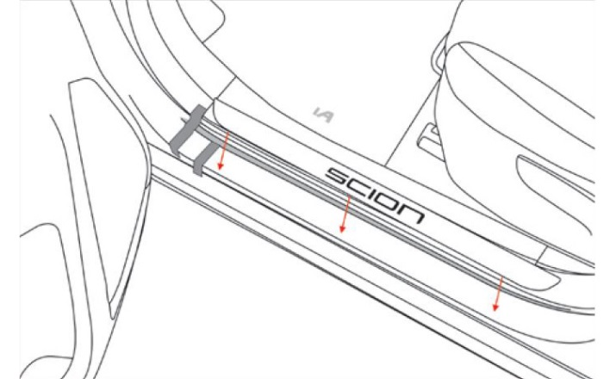

Fig. 3-1

caution_2**NOTE:** The “SCION” logo must be oriented to be read from the outside of the vehicle.

* 1. Remove the tape liner from the front door sill protector. Do not touch the adhesive.
  2. Carefully align the part on the flat area of the center of the sill (Fig. 3-1).
     1. Align the front edge/corner along the back edge of the tape from Step 3(b).
     2. Align the inside edge of the door sill protector along the character bump that runs front to rear of the sill area.

caution_2**NOTE:** DO NOT adhere the door sill protector onto the character bump radius or the curved area of the vehicle door sill. It must be centered and installed on the flat area of the vehicle door sill.

* 1. Gently touch the part into position once alignment is confirmed. The adhesive is very aggressive; once adhered it will be difficult to reposition (Fig. 3-2).

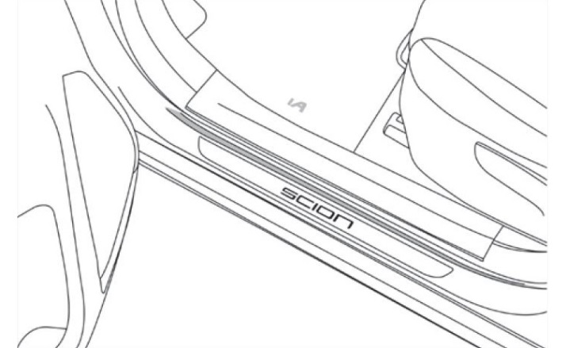

Fig. 3-2

Felt block or roller



* 1. Once positioned correctly, apply firm pressure with a soft felt block or 2” roller to ensure maximum adhesion contact. Press from the center of the door sill protector toward the edges to apply even pressure across the part and ensure uniform adhesive contact.
  2. Repeat Step 3 for the front passenger door sill.

##### Mark the Installation Location – Driver Rear Door Sill.

* 1. Place a piece of masking tape flush along the front edge of the driver rear door scuff plate (where it meets the kick panel) across the painted door sill surface to create a measurement reference line (Fig. 4-1).

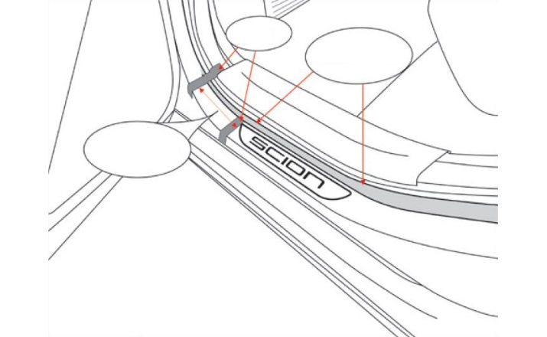

Fig. 4-1

Tape



Tape

48mm

±2mm

Character bump

* 1. Measure 48mm (±2mm) from the back edge of the tape that borders the scuff plate and place the right edge of a second piece of tape across the painted door sill surface (Fig. 4-1).
  2. Confirm the measurement from the front edge of the scuff plate to the back edge side of the second piece of tape is 48mm (±2mm).
  3. Repeat Step 4 on the rear passenger door sill area.

##### Install the Rear Door Sill Protectors.

* 1. Position a rear door sill protector over the rear driver side vehicle door sill area. Align the front edge/corner along the back edge of the tape applied in Step 4(b) to check for proper fit and orientation prior to installation (Fig. 5-1).

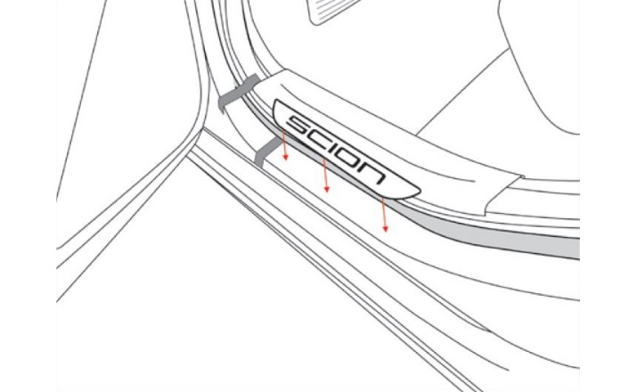

Fig. 5-1

caution_2**NOTE:** The “SCION” logo must be oriented to be read from the outside of the vehicle.

* 1. Remove the tape liner from the rear door sill protector. Do not touch the adhesive.
  2. Carefully align the part on the flat area of the center of the sill (Fig. 5-1).
     1. Align the front edge/corner along the back edge of the tape from Step 4(b).
     2. Align the inside edge of the door sill protector along the character bump that runs front to rear of the sill area.

caution_2**NOTE:** DO NOT adhere the door sill protector onto the character bump radius or the curved area of the vehicle door sill. It must be centered and installed on the flat area of the vehicle door sill.

* 1. Gently touch the part into position once alignment is confirmed. The adhesive is very aggressive; once adhered it will be difficult to reposition (Fig. 5-2).

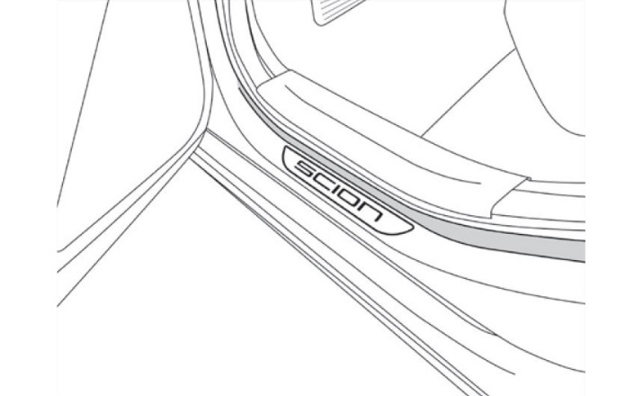

Fig. 5-2

Felt block or roller



* 1. Once positioned correctly, apply firm pressure with a soft felt block or 2” roller to ensure maximum adhesion contact. Press from the center of the door sill protector toward the edges to apply even pressure across the part and ensure uniform adhesive contact.

Accessory Function Checks

Adhesion

Alignment

Front position

Rear position

Vehicle Function Checks

Door operation

Part should be securely adhered to the vehicle

Part should be aligned parallel to the outer edges of the vehicle door sill surface

Front edge/corner of the front door sill enhancement should be 27mm (± 2mm) back from the front edge of the scuff plate

Front edge/corner of the rear door sill enhancement should be 48mm (± 2mm) back from the front edge of the scuff plate

The doors should open and close without any interference from the door sill enhancements

Vehicle Appearance Check

After accessory installation and removal of protective cover(s), perform a visual inspection.

Ensure no damage (including scuffs and scratches) was caused during the installation process.

(For PPO installations, refer to TMS Accessory Quality Shipping Standard.)